Setting up a Windward project in Eclipse

# Overview

This Windward Tutorial will cover setting up Eclipse to work with the Windward engine. The sample code included covers reading in a template (.docx, .xlsx, and .pptx formats), connecting to a database (MySql, MS SQL, DB2 and XML) and producing an output file (PDF)

This tutorial is part of the Trebuchet app, included with the Windward Java Engine. It's purpose is to help you become familiar with the Java Engine, and launch you with a high velocity into the world of simple reporting!

# Requirements

* Windward Reports Java Engine
  + Available for download at <http://www.windward.net/downloads.php>
  + Installation Tutorial
* Eclipse IDE for Java Developers
  + Available for download at <http://www.eclipse.org/downloads/>
  + Installation Tutorial
* Java JDK v1.5 or later
  + Available for download at <http://www.oracle.com/technetwork/java/javase/downloads/index.html>
  + Installation Tutorial
* Database connector - dependent on the format of your database
  + DB2
  + MS SQL
  + MySql

# Tutorial

## Step One: Create an Eclipse project

1. 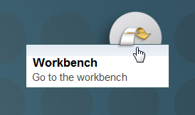  
   If Eclipse starts out at the welcome screen, you need to go to the workbench first.
2. 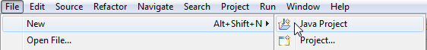  
   First click File > New > Java Project. On the first screen, name it and click Next.

## Step Two: Include the proper external libraries (jars)

1. 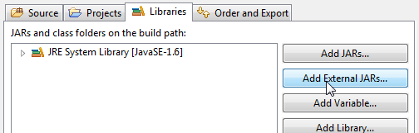  
   On the second screen, open the Libraries tab and click “Add External JARs…”
2. 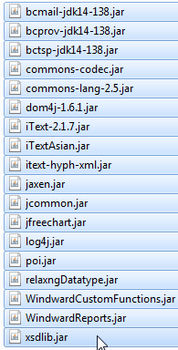  
   First and foremost, you will need the Windward JARs, these are located in the jars subfolder of the installation directory of the Windward Reports Java Engine. By default this is:  
   “C:\Program Files (x86)\Windward Studios\Windward Reports Java Engine\jars”

1. The next step depends on the type of database you are using.

|  |  |
| --- | --- |
| **XML** | XML databases do not require any additional external libraries. |
| **DB2** | By default these are located in:  “C:\Program Files (x86)\IBM\SQLLIB\java” |
| **MS SQL** | The location of this jar depends on where you unpacked the connector. One possible location is:  “C:\Program Files (x86)\Microsoft SQL Server JDBC Driver 3.0\sqljdbc_3.0\enu” |
| **MySql** | The location of this jar depends on where you unpacked the connector. One possible location is: “C:\mysql” |

## Step Three: Import Windward sample code

1. 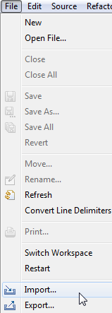  
   Click File > Import.
2. 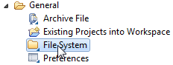  
   Select File System under General
3. 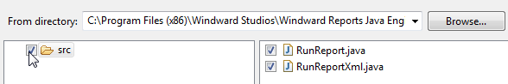Navigate to the sample code. By default this will be located at: “C:\Program Files (x86)\Windward Studios\Windward Reports Java Engine\demo\Samples\Java.” This folder is where the projects are located, and the source code is inside the src subdirectory of the respective project. You only have to select the “src” subdirectory.

## Step Four: Run the project

1. Finally, click the Run > Run menu option, or alternatively press Ctrl + F11. Assuming the project compiled and ran with success, you can view the final report in the out/report.pdf folder.  
   *Note: You might have to manually create an “out” folder in your project directory. Do this by right clicking your project in the Package Explorer, selecting New > Folder, and creating a folder called out.*
2. Double-click your project name in the “Package Explorer” on the left of the screen.
3. With your project selected, press F5 to update the Package Explorer, and then open the out folder and you should see your results in report.pdf waiting to be enjoyed!  
   